Name _______________________________________
Due Date____________________________________

Biography Character Project
- Read your biography book. In addition, feel free to research other stories, books, or articles about your character to help gather information.

- Make a list of your biography character’s traits. Character traits are a person’s special qualities. Choose four traits and write them down on the top line of each section of the brainstorming outline. Underneath each character trait, write two complete well written sentences supporting your trait. (example: Rosa Parks- courageous. She was courageous for standing up for what she believed in and not giving up her seat on the bus.

- On poster board:
  - Draw a large picture of your character in the middle of the poster.
  - Put the name of your character on the poster board large enough to read it.
  - Write each character trait sheet and the descriptions of each trait on the poster. Then decorate the rest of the poster board with information, pictures, and objects about your character.
  - Be Neat!
  - Use up all the space provided.

- Write a BIO-POEM about your character following the template below or an acrostic poem like the one we did in class. If you do an acrostic poem write phrases not just one word. It can be typed. Be neat!

First Name
Four adjectives to best describe your character
Bother of, or sister of, husband of, father of….
Lover of (2-3 different things that person loves)
Who feels (2-3 different feelings and when or where they are felt)
Who gives (2-3 different things that person gives)
Who fears (2-3 different things the person fears)
Who would like to see (2-3 different things the person would like to see)
Who lives (a brief description of where the person lived)
Last name

EXAMPLE of a character in a book

Tom
Tall, tasty, feathery, vicious,
Sibling of Clucky Chicken and Big Bird,
Lover of vegetarians and ham eaters,
Fears Mr. Butterball and pilgrims,
Needs to run around,
Gives nourishment and leftovers,
Would like to see birds unite and revolt,
Resident of Old MacDonald’s Farm
Turkey

Character trait #1 | Character trait #2
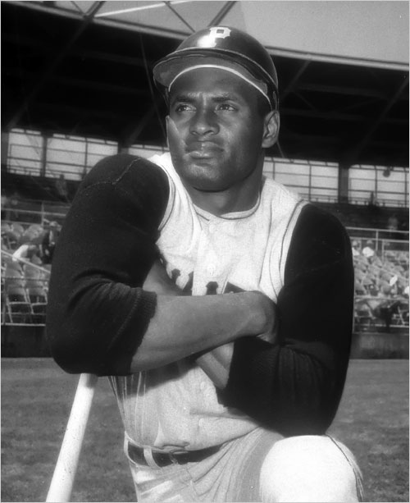
Character trait #3 | Character trait #4

Character trait #1

___________________________________________________________________

___________________________________________________________________

___________________________________________________________________

___________________________________________________________________

___________________________________________________________________

___________________________________________________________________

___________________________________________________________________

Character trait #2

___________________________________________________________________

___________________________________________________________________

___________________________________________________________________

___________________________________________________________________

___________________________________________________________________

___________________________________________________________________

___________________________________________________________________

Character trait #3

___________________________________________________________________

___________________________________________________________________

___________________________________________________________________

___________________________________________________________________

___________________________________________________________________

___________________________________________________________________

___________________________________________________________________

Character trait #4

___________________________________________________________________

___________________________________________________________________

___________________________________________________________________

___________________________________________________________________

___________________________________________________________________

___________________________________________________________________

___________________________________________________________________

